Title of presentation:
Neuroprosthetic technologies
to improve locomotion after spinal cord injury
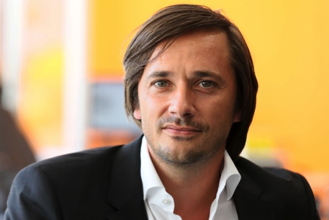 | COURTINE  Grégoire  Swiss Federal Institute of Tehcnology  Professor, International Paraplegic Foudation chair in Spinal Cord Repair  http://courtine-lab.epfl.ch/
Short abstract:
Over the past decade, my team and I developed an intervention that restored supraspinal control of leg movements after functionally complete spinal cord injuries in rodents. This therapy, termed neuroprosthetic rehabilitation, acts over two time windows. In the short-term, electrical and chemical neuromodulation of the lumbar spinal cord mediate motor control of the paralysed legs. In the long term, will-powered training regimens enabled by electrochemical neuromodulation and robotic assistance promote neuroplasticity of residual connections—an extensive rewiring that reestablishes voluntary movement. The implementation of these interventions required the development of cutting-edge technologies, including next-generation neural implants, advanced computational models, real-time control platforms, novel robotic systems, detailed behavioral readouts and high-resolution anatomical analyses. Here, I will describe the conceptual and technological framework through which we designed this neuroprosthetic toolbox. I also will reveal some of the mechanisms underlying the immediate and long-term effects of neuroprosthetic rehabilitation on motor control capacities. Finally, I will highlight our current efforts in non-human primates and humans to translate our findings into a viable therapy to improve motor recovery in paraplegic individuals.

