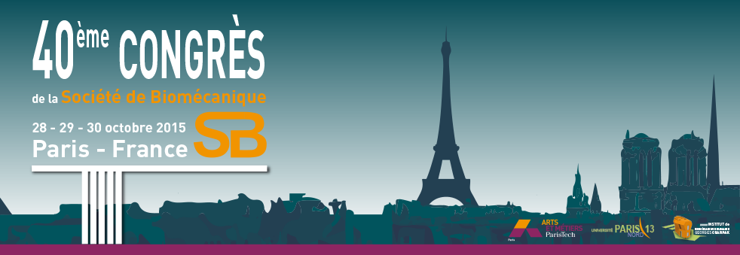
Partnership Form
Company :
Website :
Address :
City : Country :
Contact
Surname : Name :
Phone : Email :
Thick the elements you want to book:
◻ Insertion of your logo on the cover of the congress program, on the website and link to the company website.

Price: 500€

◻ Insertion of your logo on the cover of the congress program, on the website and link to the company website.
Registration to the congress for 1 person.
Wifi connection, 1 congress pack, 1 copy of the congress proceedings.
Lunch and coffee breaks.

Price: 1000€

◻ Stand including 1 table, 2 chairs, 1 power point.
Insertion of your logo on the cover of the congress program, on the website and link to the company website.
Registration to the congress for 1 person.
Partenrship with the prize for the best talk for each session.
Wifi connection, 1 congress pack, 1 copy of the congress proceedings.
Lunch and coffee breaks.

Price: 2000€

◻ Option: Partnership with the prize for the best talk for each session. Allow you to hand the best talk prize over to the winner with the possibility to present your company and products after the session in a 3 minutes power point presentation. 1 winner per session with a total of 12 sessions. Possibility to choose the session you wants to participate.

Price: 500€

◻ Option: Registration to the congress for ……. supplementary person(s)

Price: 500€

Payment mode
◻ Bank check to the order of Congrès SB 2015 ◻ Bank transfer
Bank account details will be sent upon receipt of the present form

For any further information : sb2015-paris@sciencesconf.org - Phone 01 44 24 63 64

